FreelanceFinder – Discovering Opportunities, Unlocking Potential
1.Introduction
- Project title : FreelanceFinder – Discovering Opportunities, Unlocking Potential
- Team Leader : Janga Srinivasa Reddy
- Team member : Megha Sindhu Indukuri
- Team member : Lohitha Sri Vasavi Kanikalla
- Team member : M S S C Kumar
2. Project Overview
Purpose:
The purpose of the FreelanceFinder platform is to provide a secure, structured, and scalable freelancing environment for Clients, Freelancers, and Administrators. By leveraging the MERN stack architecture and modern authentication mechanisms, FreelanceFinder enables efficient project management, proposal submission, real-time communication, secure collaboration, and workflow tracking.
For Clients, the platform offers structured project posting, proposal review, and project monitoring features. For Freelancers, it provides a dedicated dashboard to browse projects, submit proposals, communicate in real time, and manage submissions. For Administrators, the system ensures centralized control, user monitoring, and platform security through role-based authentication.
Ultimately, FreelanceFinder bridges technology and professional collaboration by creating an efficient, transparent, and secure freelancing ecosystem that supports remote work and skill-based project execution.

Features:
1. Role-Based Authentication System
Key Point: Secure access control
Functionality: Implements JWT-based authentication and bcrypt password hashing to manage Admin, Client, and Freelancer roles securely.
2. Structured Project Management
Key Point: Organized workflow
Functionality: Allows clients to create and manage projects with title, description, required skills, budget, and deadline.
3. Proposal Submission System
Key Point: Transparent selection process
Functionality: Freelancers can submit structured proposals; clients can review and select candidates.
4. Real-Time Chat System
Key Point: Seamless communication
Functionality: Integrates Socket.io to enable real-time messaging between clients and freelancers.
5. Project Tracking System
Key Point: Workflow monitoring
Functionality: Tracks project status (Open, In Progress, Completed) and manages submissions.
6. Dedicated Dashboards
Key Point: Organized role-based interface
Functionality: Separate dashboards for Admin, Client, and Freelancer to manage platform activities efficiently.
7. RESTful API Communication
Key Point: Seamless integration
Functionality: Uses REST APIs and Axios for secure frontend-backend communication.
8. Secure Data Management
Key Point: Reliable data storage
Functionality: Stores user, project, application, and chat data in MongoDB using structured schemas.
9. Responsive User Interface
Key Point: User-friendly experience
Functionality: Developed using React.js and Bootstrap/Material UI to ensure accessibility across devices.

3. Architecture
Frontend (React.js)
The frontend of FreelanceFinder is developed using React.js, providing an interactive and dynamic web interface for Clients, Freelancers, and Administrators. The application includes multiple pages such as Home, Login, Register, Admin Dashboard, Client Dashboard, Freelancer Dashboard, Project Listing, Proposal Submission, Chat Interface, and Project Tracking. Routing is handled using React Router, and API communication is managed through Axios. The UI is responsive and modularized for scalability and maintainability.

Backend (Node.js & Express.js)
The backend is built using Node.js and Express.js, serving as the RESTful API framework. It manages authentication, project creation, proposal handling, freelancer selection, chat integration, and project status tracking. The backend follows a structured MVC-like architecture with separate folders for routes, controllers, middleware, and schemas.

Authentication & Security (JWT & bcrypt)
Authentication is implemented using JWT for secure session management and bcrypt for password hashing. After login, a token is generated and attached to protected API requests. Role-based access control ensures Admin, Client, and Freelancer functionalities are securely separated.

Database (MongoDB & Mongoose)
FreelanceFinder uses MongoDB as its NoSQL database with Mongoose for schema modeling. Data collections include:
- Users
- Projects
- Applications
- Chats
Relationships are maintained using object references to ensure structured data flow.

Real-Time Communication (Socket.io)
Socket.io enables instant messaging between clients and freelancers. Chat messages are stored in the database and associated with specific projects.

API Communication (REST & Axios)
Communication between frontend and backend is handled using RESTful APIs, with Axios managing secure requests. Protected routes require JWT tokens.

4. Setup Instructions
Prerequisites:
- Node.js (v16 or later)
- npm (Node Package Manager)
- MongoDB (Local or MongoDB Atlas)
- Git
- Internet connection
Installation Process:
- Clone the repository.
- Navigate to backend directory and run:
npm install
- Navigate to frontend directory and run:
npm install
- Create a .env file in backend folder and configure:
  - MONGO_URI
  - JWT_SECRET
  - PORT
- Start backend using:
npm start
- Start frontend using:
npm run dev
- Open browser at:
http://localhost:5173

5. Folder Structure
Backend Structure
config/ – Database configuration
controllers/ – Business logic (auth, projects, proposals, chat)
middlewares/ – JWT authentication & role protection
routes/ – API endpoints
schemas/ – Mongoose models
uploads/ – File storage (if attachments added)
server.js – Backend entry point
Frontend Structure
src/components/
- admin/
- client/
- freelancer/
- common/
AxiosInstance.js – Configured Axios
App.js – Routing
main.jsx – Entry point

6. Running the Application
- Start backend server.
- Start frontend application.
- Register/Login as Admin, Client, or Freelancer.
- Clients post projects.
- Freelancers submit proposals.
- Users communicate via chat.
- Projects are completed and tracked dynamically.

7. API Documentation
POST /users/register – Register new user
POST /users/login – Authenticate user
POST /projects/create – Create project (Client)
GET /projects – View projects
POST /applications/submit – Submit proposal
POST /projects/select – Select freelancer
GET /chat/:projectId – Fetch chat messages
POST /chat/send – Send message
GET /admin/users – View users

8. Authentication
Implemented using:
- JWT for session management
- bcrypt for password hashing
- Role-based middleware protection
- Token verification for protected routes
Future Enhancements:
- OAuth login (Google/GitHub)
- Refresh tokens
- Multi-factor authentication

9. User Interface
The interface includes:
- Navigation bar
- Role-based dashboards
- Project cards with details
- Proposal submission forms
- Real-time chat interface
- Project status indicators
- Responsive design

10. Testing
Unit Testing:
Authentication logic, proposal submission, and chat functionality tested.
API Testing:
Endpoints tested using Postman.
Manual Testing:
Registration, login, project posting, proposal submission, chat, and project completion tested.
Edge Case Handling:
Handled invalid credentials, duplicate proposals, unauthorized access, and missing project details.
11.Screen Shots
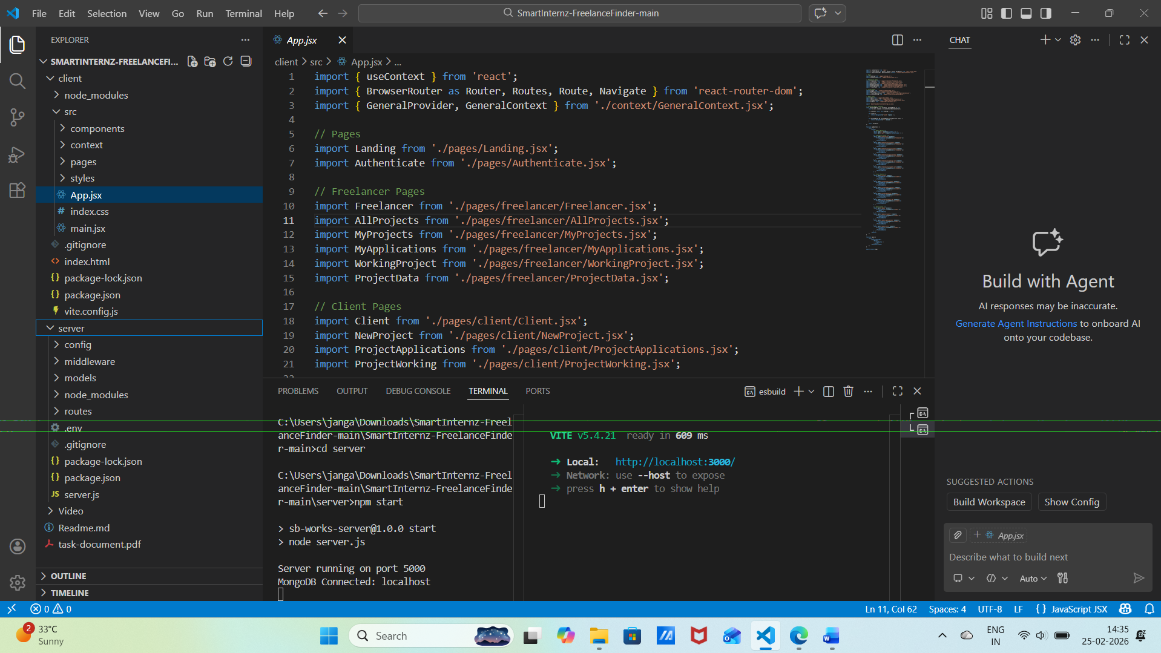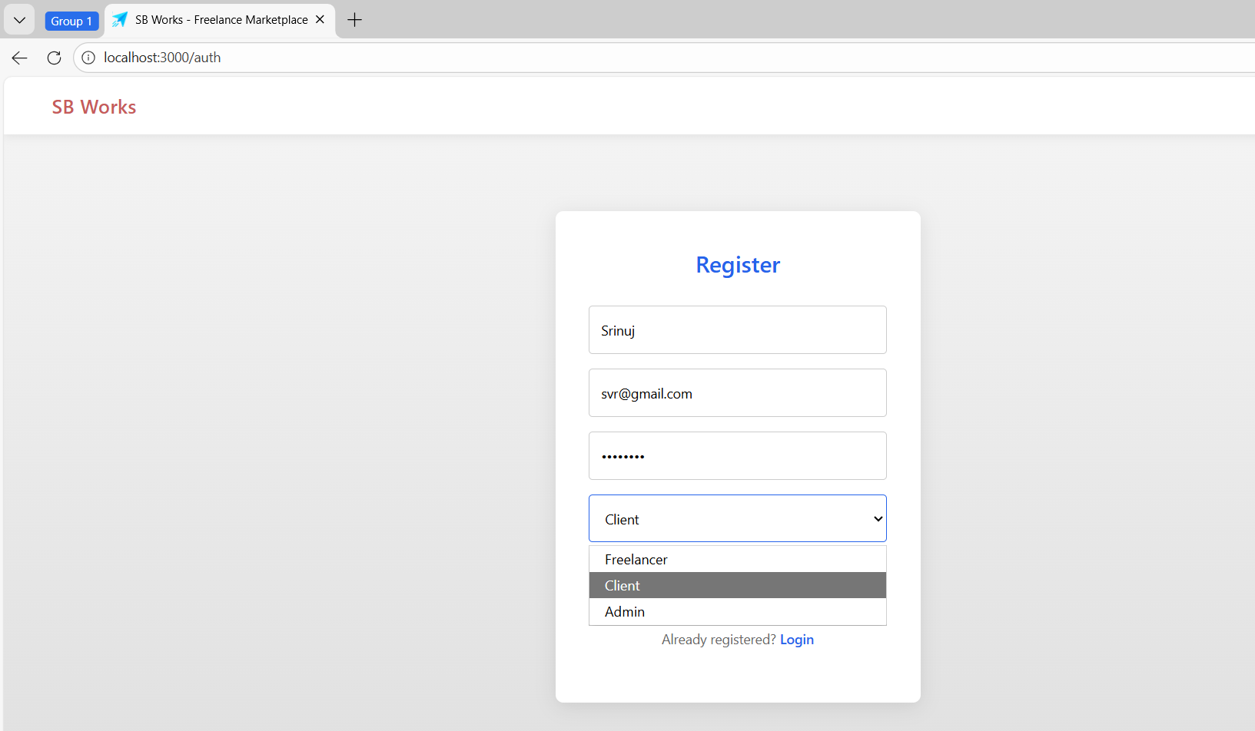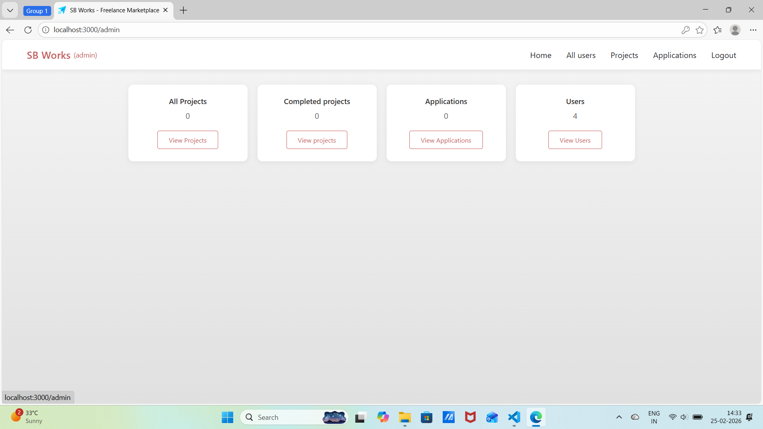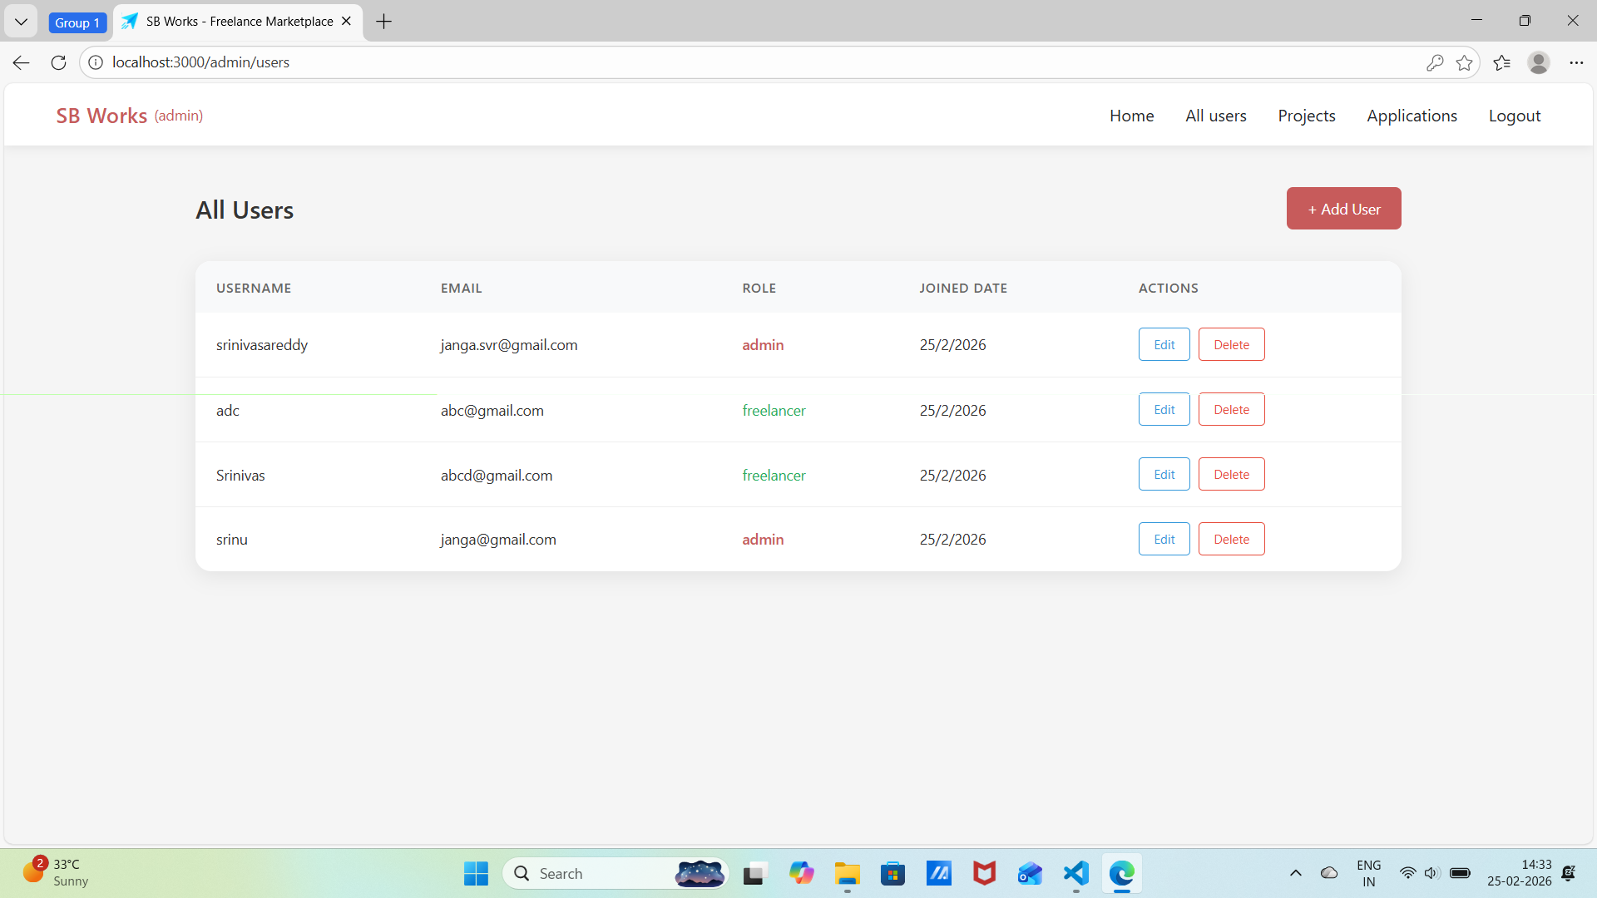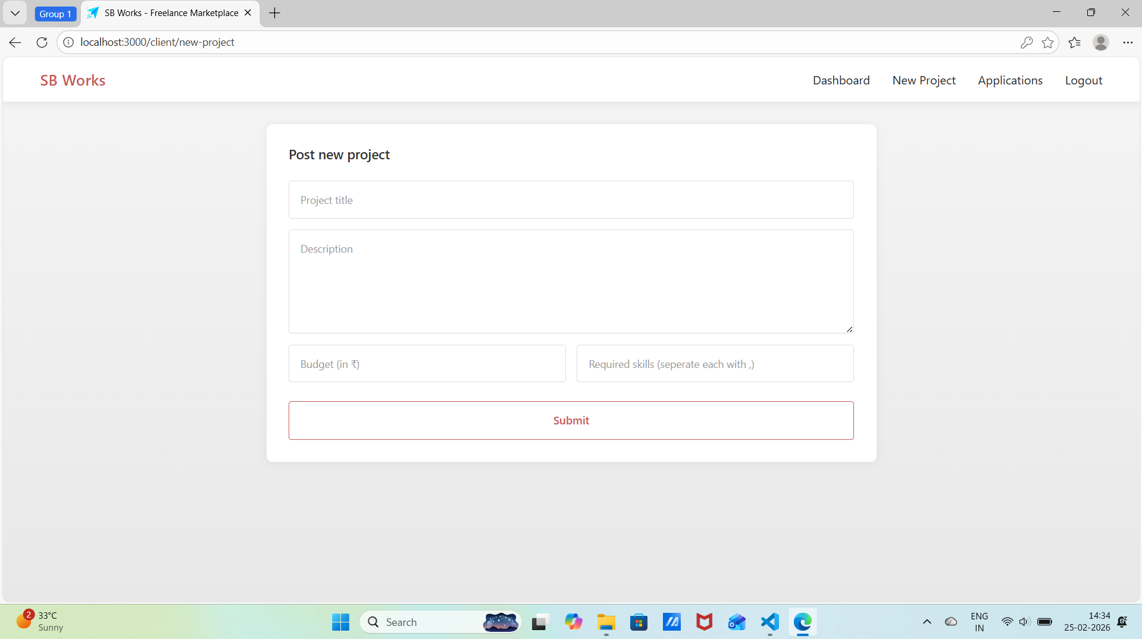

12. Known Issues
File uploads (if enabled) are stored locally, which may cause storage limitations in large-scale deployments.
• No real payment gateway integration for project transactions or commission handling (if monetization is added).
• No cloud storage integration for file attachments (e.g., AWS S3 or Google Cloud).
• Limited scalability in demo/local environment for handling large concurrent user traffic.
• No refresh token mechanism implemented for long session management.
• Limited advanced input validation for certain form fields (e.g., budget limits, proposal formatting validation).
• No real-time notification system for project updates or proposal status changes.
• Performance may reduce with large datasets due to non-optimized MongoDB indexing.
• No AI-based freelancer or project recommendation system.
• Requires manual deployment configuration for production hosting.

13. Future Enhancements
• AI-Based Project & Freelancer Recommendation System
Functionality: Implement machine learning algorithms to suggest relevant projects to freelancers and recommend suitable freelancers to clients based on skills, activity history, and ratings.
• Multilingual Platform Support
Functionality: Add multiple language options to make the platform accessible to global users.
• Real-Time Notification System
Functionality: Implement WebSocket-based notifications for proposal updates, project status changes, and admin announcements.
• Real Payment Gateway Integration
Functionality: Integrate Razorpay, Stripe, or PayPal to enable secure real-time project payments and commission processing.
• Cloud-Based File Storage
Functionality: Store attachments and project files on AWS S3 or Google Cloud Storage for better scalability and reliability.
• Advanced Analytics Dashboard
Functionality: Provide detailed insights including freelancer performance metrics, client activity trends, and project success statistics.
• Dispute Resolution System
Functionality: Add structured workflows for handling project disputes between clients and freelancers.
• Docker-Based Deployment & CI/CD
Functionality: Use Docker containers and GitHub Actions for automated deployment, scalability, and continuous integration.
• Long-Term Performance Tracking
Functionality: Track freelancer ratings and project performance trends over time for analytics and reputation management.
• Mobile Application Development
Functionality: Develop Android and iOS mobile applications to increase accessibility and user engagement.
• Enhanced Input Validation & Security Improvements
Functionality: Implement stronger schema validation, rate limiting, refresh tokens, and multi-factor authentication for improved security.

